"Enhancing Poultry Growth and Survival Rates: A Comparative Study of Automated and Traditional Farming Practices in Bangladesh."

**Abstract:**

Poultry farming in regions prone to harsh weather conditions during the winter season demands innovative solutions to mitigate risks and enhance productivity. In this study, we investigate the impact of automation on poultry farming resilience in the context of Bangladesh's challenging climate. A comparative analysis was conducted between a controlled environment shed equipped with automated climate control systems and a traditional setup. The controlled environment shed featured real-time monitoring and adjustment of temperature, humidity, and ammonia levels using sensors and Arduino microcontrollers. Six DHT11 sensors were employed to monitor temperature and humidity, while two MQ137 sensors measured ammonia levels. Data were recorded and analyzed to evaluate the effectiveness of the automated system.

Our results indicate significant improvements in both growth and mortality rates in the controlled environment shed compared to the traditional setup. Chicken growth exhibited a remarkable 26.19% increase, accompanied by a 13.33% reduction in mortality rates. Furthermore, statistical analysis revealed lower variability in temperature, humidity, and gas levels within the controlled environment, as evidenced by lower standard deviations and mean variances. These findings underscore the efficacy of automated climate control systems in poultry farming, particularly in mitigating the adverse effects of harsh weather conditions. By maintaining optimal environmental conditions, such systems offer a viable solution to enhance productivity and resilience in poultry farming operations, contributing to food security and economic sustainability in regions vulnerable to climate extremes.

Chapter 1

**Introduction**

* 1. **Background and Rationale for the Study**

The poultry industry in Bangladesh has experienced significant growth, about 15% per year, with a rise in per capita egg consumption and the development of allied industries [1] [2]. But harsh weather conditions pose significant challenges, particularly in regions like Dinajpur. With winter temperatures plummeting to as low as 10°C and humidity levels dropping to 28%, poultry farmers encounter substantial difficulties in maintaining optimal conditions for bird health and productivity. It was reported that about 20,000 poultry farms suspended their operation during December-January of 2023-2024. [3]

Traditional farming methods are often inadequate in mitigating the adverse effects of extreme temperatures, humidity, and gas levels, leading to reduced poultry growth and productivity. This study aims to investigate the potential of automation in addressing these challenges faced by poultry farmers. By implementing a controlled environment with automated systems for temperature, humidity, and gas level management, we seek to assess the impact of these technological interventions on poultry production outcomes, specifically growth rates and mortality rates.

The research contributes to the broader discourse on sustainable agriculture and technology adoption in developing countries. Demonstrating the feasibility and benefits of automated systems in mitigating weather-related risks in poultry farming has implications for food security, livelihoods, and policy-making in similar agro-climatic contexts.

**1.2 Overview of Poultry Farming in Bangladesh and the Impact of Harsh Weather**

Poultry farming in Bangladesh plays a vital role in the country's economy, contributing approximately 1.5 to 1.6 percent of the GDP and providing employment to around 6 million people [4]. This sector significantly contributes to meeting the nation's meat demand, fulfilling approximately 36% of the requirement in 2019. Notably, poultry farming plays a crucial role in rural economic growth and women's empowerment, offering opportunities for livelihood and income generation. In terms of production and types, Bangladesh hosts over 53,000 broiler farms and 18,000 layer farms. Broilers dominate the sector, constituting 58.39% of chickens, followed by Sonali and layers at 28% and 8.23%, respectively. Annually, the poultry industry produces an impressive 1.25 trillion eggs, highlighting its substantial output and contribution to the nation's food security[4]. Yet it encounters significant challenges during the harsh winter months, typically from December to February. During this period, temperatures drop significantly, and humidity levels decline, posing various difficulties for poultry farmers. Chickens experience reduced feed intake and growth rates as they expend more energy to maintain body heat, while their weakened immune systems make them more susceptible to diseases like respiratory infections. Consequently, mortality rates among poultry flocks rise due to the compounded effects of stress, reduced feed intake, and disease risks. These challenges have notable economic repercussions, leading to longer production cycles, delayed market entry, and decreased income for farmers. To address these issues, effective mitigation strategies are imperative, focusing on maintaining stable environments within poultry sheds to promote bird health, growth, and overall production efficiency despite the harsh winter conditions.

Chapter 2

**Literature Review**

Kocaman’s [5] study examines how environmental factors like ammonia, carbon dioxide, hydrogen sulfide, dust, temperature, and humidity affect the performance of laying hens. Optimal temperature and humidity levels are crucial for the health and performance of laying hens, with recommended values being 15-20°C and 60-70% relative humidity. We had utilized this findings to set threshold for temperature and humidity parameter in hour shed.

Lara reviewed the impact of heat stress on poultry production, particularly focusing on broilers and laying hens. According to their study, heat stress leads to a range of physiological changes in birds, including altered behavior, reduced feed intake, and impaired reproductive function. They also suggested various strategies to mitigate heat stress, such as environmental management, nutritional manipulation, and genetic selection for heat tolerance. [6]

A study on climate change in poultry production was done by Ahatou. The paper reviews how environmental challenges, particularly heat stress, affect poultry performance. Poultry have specific thermoregulatory mechanisms to cope with temperature changes. These include panting, seeking shade, and adjusting their metabolic rate. However, extreme temperature can overwhelm these mechanisms.[7]

Research done by Zeyad indicates that the optimal temperature and humidity for poultry farming are 20-25°C and 60-80% respectively [8]. To achieve these conditions, energy-efficient evaporative cooling systems such as direct, indirect, and Maisotsenko-Cycle evaporative cooling have been developed by Shahzad [9]. These systems can decrease temperature by 5-12°C and reduce the temperature-humidity index by 3-10°C. However, in the context of Bangladesh, less expensive systems are effective, so we went on with simple heater and humidifier along with exhaust fan.

Finally we’ve found that it is important to maintain these optimal conditions, as temperatures above 26°C and a relative humidity of more than 40% can lead to heat stress in poultry [10].

Excessive ammonia in poultry farming has a range of negative effects on both the birds and the environment. Sheikh and Kristensen both highlight the detrimental impact on bird health, including reduced body weight gain, feed conversion, and immune system function [11] [12]. This can lead to increased susceptibility to respiratory diseases and decreased welfare. Sousa further emphasizes the economic losses and environmental damage caused by high ammonia concentrations. These findings underscore the importance of controlling ammonia levels in poultry farming to ensure both animal welfare and economic sustainability [13].

The optimal ammonia level for poultry production is a critical factor, with Sheikh and Czarick both suggesting that levels should not exceed 25 ppm to avoid adverse effects on bird health and performance [11] [14].

A range of techniques have been proposed to reduce ammonia emissions in poultry farms. Singh suggests the use of a urease inhibitor to block enzyme activity in the litter [15], while Lahav proposes a system that captures ammonia-rich air and converts it to ammonium [16]. Rothrock explores the use of gas-permeable membranes to capture and recover ammonia from poultry litter, and Bejan reviews chemical methods for ammonia treatment, favoring electrochemical hypochlorination [17] [18]. These studies provide a variety of potential solutions for reducing ammonia emissions in poultry farms.

Despite the existing research on ammonia emissions from poultry farms, there are several knowledge gaps that warrant further investigation. Firstly, there is a need for more in-depth studies on specific techniques and technologies for controlling and reducing ammonia emissions in poultry farming operations. Additionally, research focusing on the development and implementation of integrated management practices that address multiple environmental and public health concerns associated with poultry farming is essential. Future studies could also explore the economic and operational feasibility of adopting ammonia control measures in poultry farms, as well as the potential for scaling up successful interventions to the industry level.

A range of studies have explored the use of Arduino in poultry automation. Soh (2017) developed an automatic chicken feeder using Arduino Uno, which improved feeding efficiency and reduced labor costs [19]. Goswami (2022) implemented an automatic lighting and heating system for poultry farms, enhancing the environment for chicken growth [20]. Raghudathesh (2017) built an IoT-based intelligent poultry management system using Arduino Mega and Raspberry Pi, which effectively monitored and regulated environmental parameters. These studies collectively demonstrate the potential of Arduino in enhancing poultry automation, from feeding and environmental control to overall management [21].

Chapter 3

**Methodology**

**3.1 Description of the Experimental Setup**

The controlled environment shed featured automated systems for temperature, humidity, and ammonia gas level regulation, utilizing sensors connected to an Arduino microcontroller. Insulated materials maintained stable internal conditions, with heaters and humidifiers activated as needed to adjust temperature and humidity levels. Additionally, MQ137 gas sensors monitored ammonia levels, triggering ventilation fans when concentrations exceeded set thresholds. In contrast, the traditional setup lacked automated controls, relying on standard poultry farming practices and external weather conditions. Identical chicken breeds and ages were housed in both environments, with data collection conducted simultaneously using sensor readings recorded at regular intervals.

**3.2 Description of the Study Location (Dinajpur, Bangladesh)**

Winter in Dinajpur, with its notably cooler temperatures averaging around 15°C and occasionally dipping below 10°C, presents significant challenges for poultry farmers. These cold conditions demand careful management of environmental conditions within poultry sheds to maintain flock health and productivity. Additionally, the accompanying drop in humidity levels to around 28% or lower exacerbates the impact of cold weather on poultry, heightening susceptibility to respiratory ailments and stress-related issues. Despite these challenges, Dinajpur's diverse agricultural landscape, where farming is a primary livelihood for many residents, highlights the significance of poultry farming in the region. This sector not only offers employment opportunities but also plays a crucial role in enhancing local food security and nutrition.

Research Site:

To conduct our study, we established two poultry sheds within the premises of Hajee Mohammad Danesh Science and Technology University in Dinajpur. This location was chosen due to its accessibility and the collaborative efforts of faculty members and students from the Doctor of Veterinary Medicine discipline. The site was meticulously designed and developed to accommodate our experimental needs and ensure optimal performance. The collaboration with veterinary experts allowed us to integrate insights from animal health and welfare into the design and management of the experimental setup, enhancing the scientific rigor and relevance of our research. By utilizing facilities within our university, we were able to closely monitor and oversee the implementation of our study, facilitating seamless coordination and data collection processes.

**3.3 Details of the Sensors Used and Their Placement**

In our controlled environment shed, six DHT11 sensors were strategically placed to monitor temperature and humidity levels. Evenly distributed across different sections, these sensors provided comprehensive data while minimizing measurement variations. Additionally, two MQ137 gas sensors were positioned at the shed's center to monitor ammonia levels, crucial for air quality and poultry health. Both sets of sensors were strategically located to ensure representative measurements and efficient data collection. This placement strategy, informed by factors like airflow patterns and accessibility, aimed to optimize the reliability and effectiveness of our monitoring system, enabling thorough analysis of environmental conditions and their impact on poultry production.

|  |  |  |
| --- | --- | --- |
| T1R1  Sensor 1 | Sensor 8  Corridor  Sensor 7 | T2R1  Sensor 4 |
| T1R2  Sensor 2 | T2R2  Sensor 5 |
| T1R3  Sensor 3 | T2R3  Sensor 5 |

|  |  |  |
| --- | --- | --- |
| **Parameter** | **Appliance** | **Trigger** |
| Temperature | Heater x2 | <20°C , >30°C |
| Humidity | Humidifier x2 | <50% |
| NH3 concentration | Ventilation Fan x5 | >25ppm |

Table 1: Automation Variables and Sensor Placement

**3.4 Overview of the Arduino Microcontroller and Its Role in Controlling Environmental Variables** The Arduino microcontroller, the centerpiece of our automated environmental control system, facilitated real-time monitoring and regulation of crucial variables in the controlled environment shed.

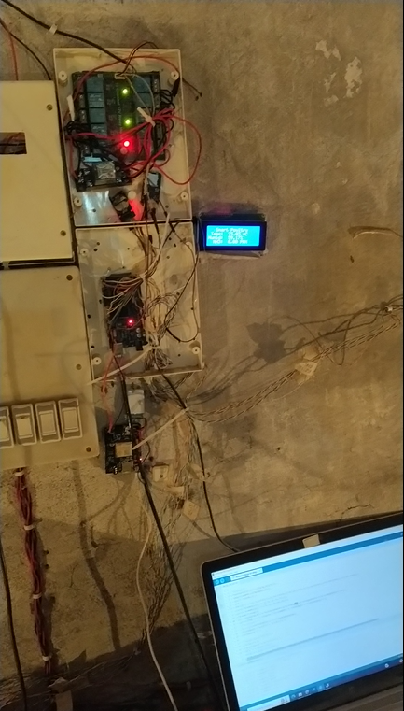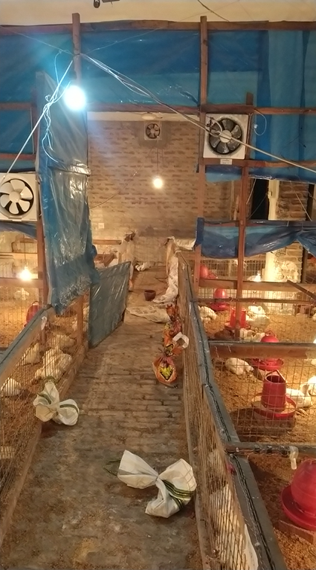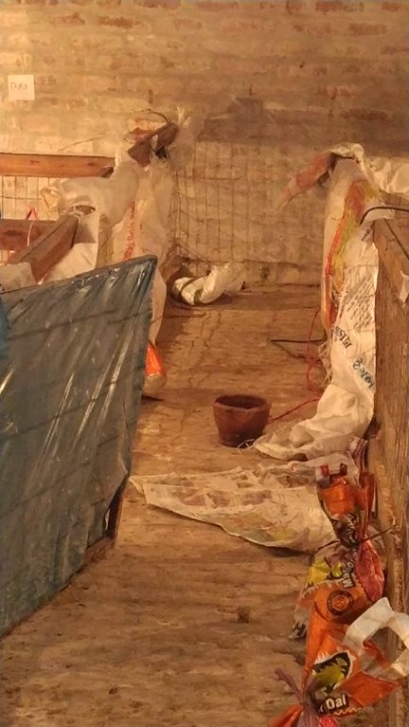

Fig 1: Controlled Shed

It interfaced with sensors and actuators to maintain optimal conditions for poultry, adjusting temperature, humidity, and ammonia gas levels as necessary. Two heaters controlled by the Arduino maintained temperature levels, activating when readings fell below preset thresholds. Similarly, two humidifiers regulated humidity, triggered by the Arduino in response to low readings. Additionally, ventilation fans managed air circulation, activated by the Arduino when ammonia levels exceeded acceptable limits, thus ensuring optimal air quality for poultry health.

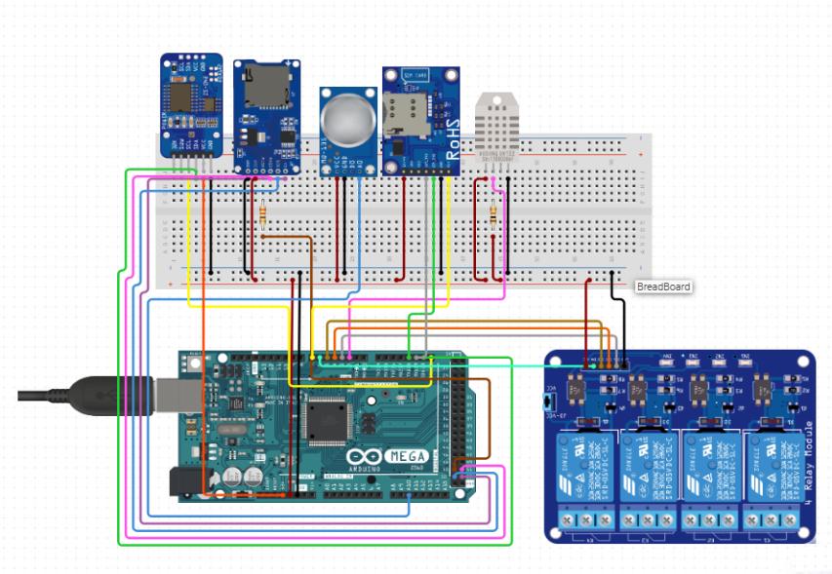

Fig 2: Simplified Circuit Diagram

**3.5 Explanation of Data Collection and Analysis Procedures**

Our study employed a sensor network interfaced with the Arduino microcontroller for comprehensive data collection, capturing real-time environmental data using DHT11 sensors for temperature and humidity monitoring, and MQ137 sensors for ammonia detection. A strategic placement of these sensors within the controlled environment shed ensured regular data collection intervals. Additionally, an SD card

reader module facilitated continuous data logging onto an SD card, providing a comprehensive dataset documenting fluctuations in temperature, humidity, and ammonia levels over time. Daily summary reports, generated by the Arduino and transmitted via a GSM module, enabled timely updates on environmental 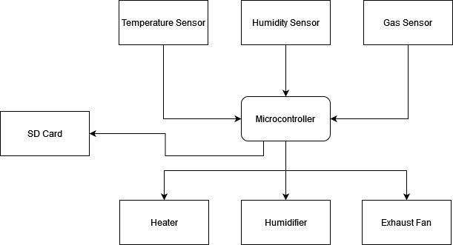conditions, facilitating remote monitoring and management.

Fig 3: Simplified System Diagram

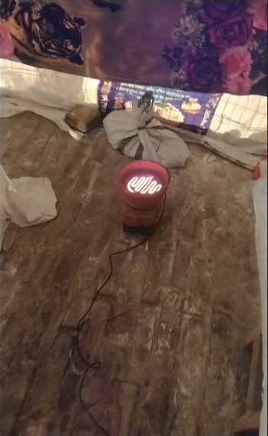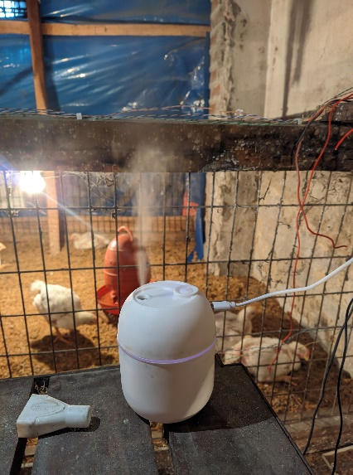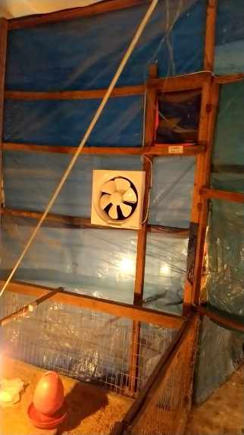

Figure 4: Appliances

Following data collection, rigorous analysis was conducted using statistical techniques like mean, standard deviation, and variance, alongside regression analysis OLS(Ordinary Least Squared) analysis and correlation studies to identify relationships between environmental parameters and poultry production outcomes. Visualizations using graphs and charts aided interpretation, revealing the impact of automation on mitigating weather-related risks and enhancing poultry production outcomes. Validation and peer review by peers from the Doctor of Veterinary Medicine discipline ensured the credibility and reliability of our findings, incorporating feedback to enhance the study's integrity.

Chapter 4

**Result**

**4.1 Presentation of the Data Collected from the Experiment**

The data collected from the experiment revealed notable differences in temperature and humidity levels between the controlled environment shed and the traditional setup. In the controlled environment shed, the average temperature was maintained at 22.70°C, with a standard deviation of 1.5, indicating minimal variability in temperature. Similarly, humidity levels were consistently maintained within the optimal range, with an average relative humidity of 75.7% and a standard deviation of 6.23.

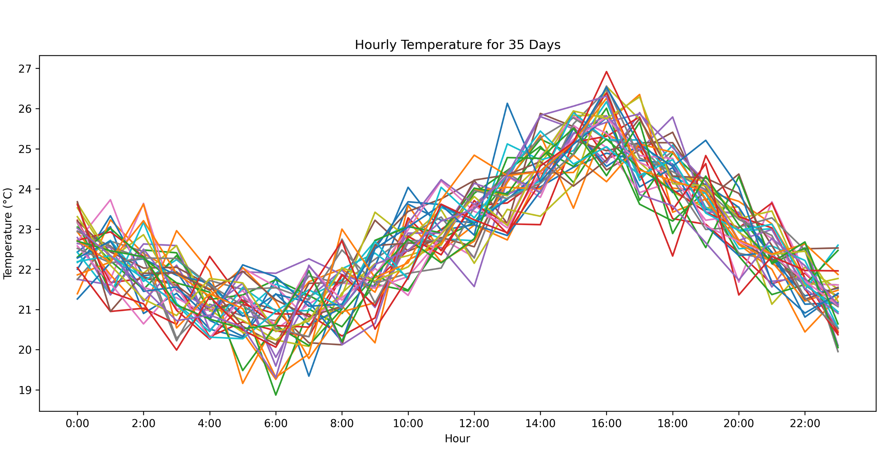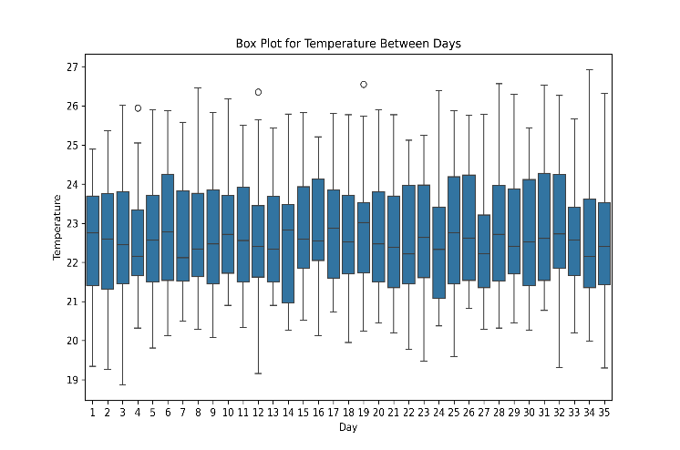

Figure 5: Temperature Vs Hour For 35 Days.

In contrast, the traditional setup exhibited greater fluctuations in temperature and humidity, with average values of 17.6°C and 54.97% for temperature and humidity, respectively. The standard deviations for temperature and humidity were considerably higher compared to the controlled environment shed, indicating greater variability and less stable conditions.

Analysis of the data also revealed differences in ammonia levels between the two environments. In the Figure 6: Humidity Vs Hour For 35 Days

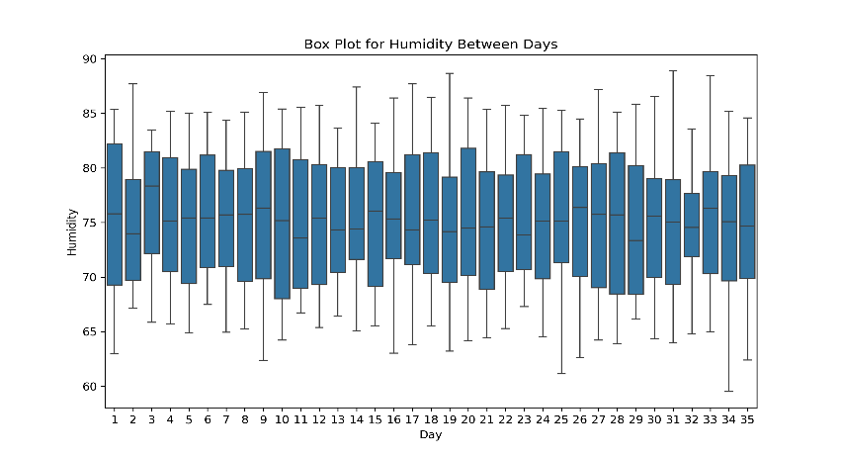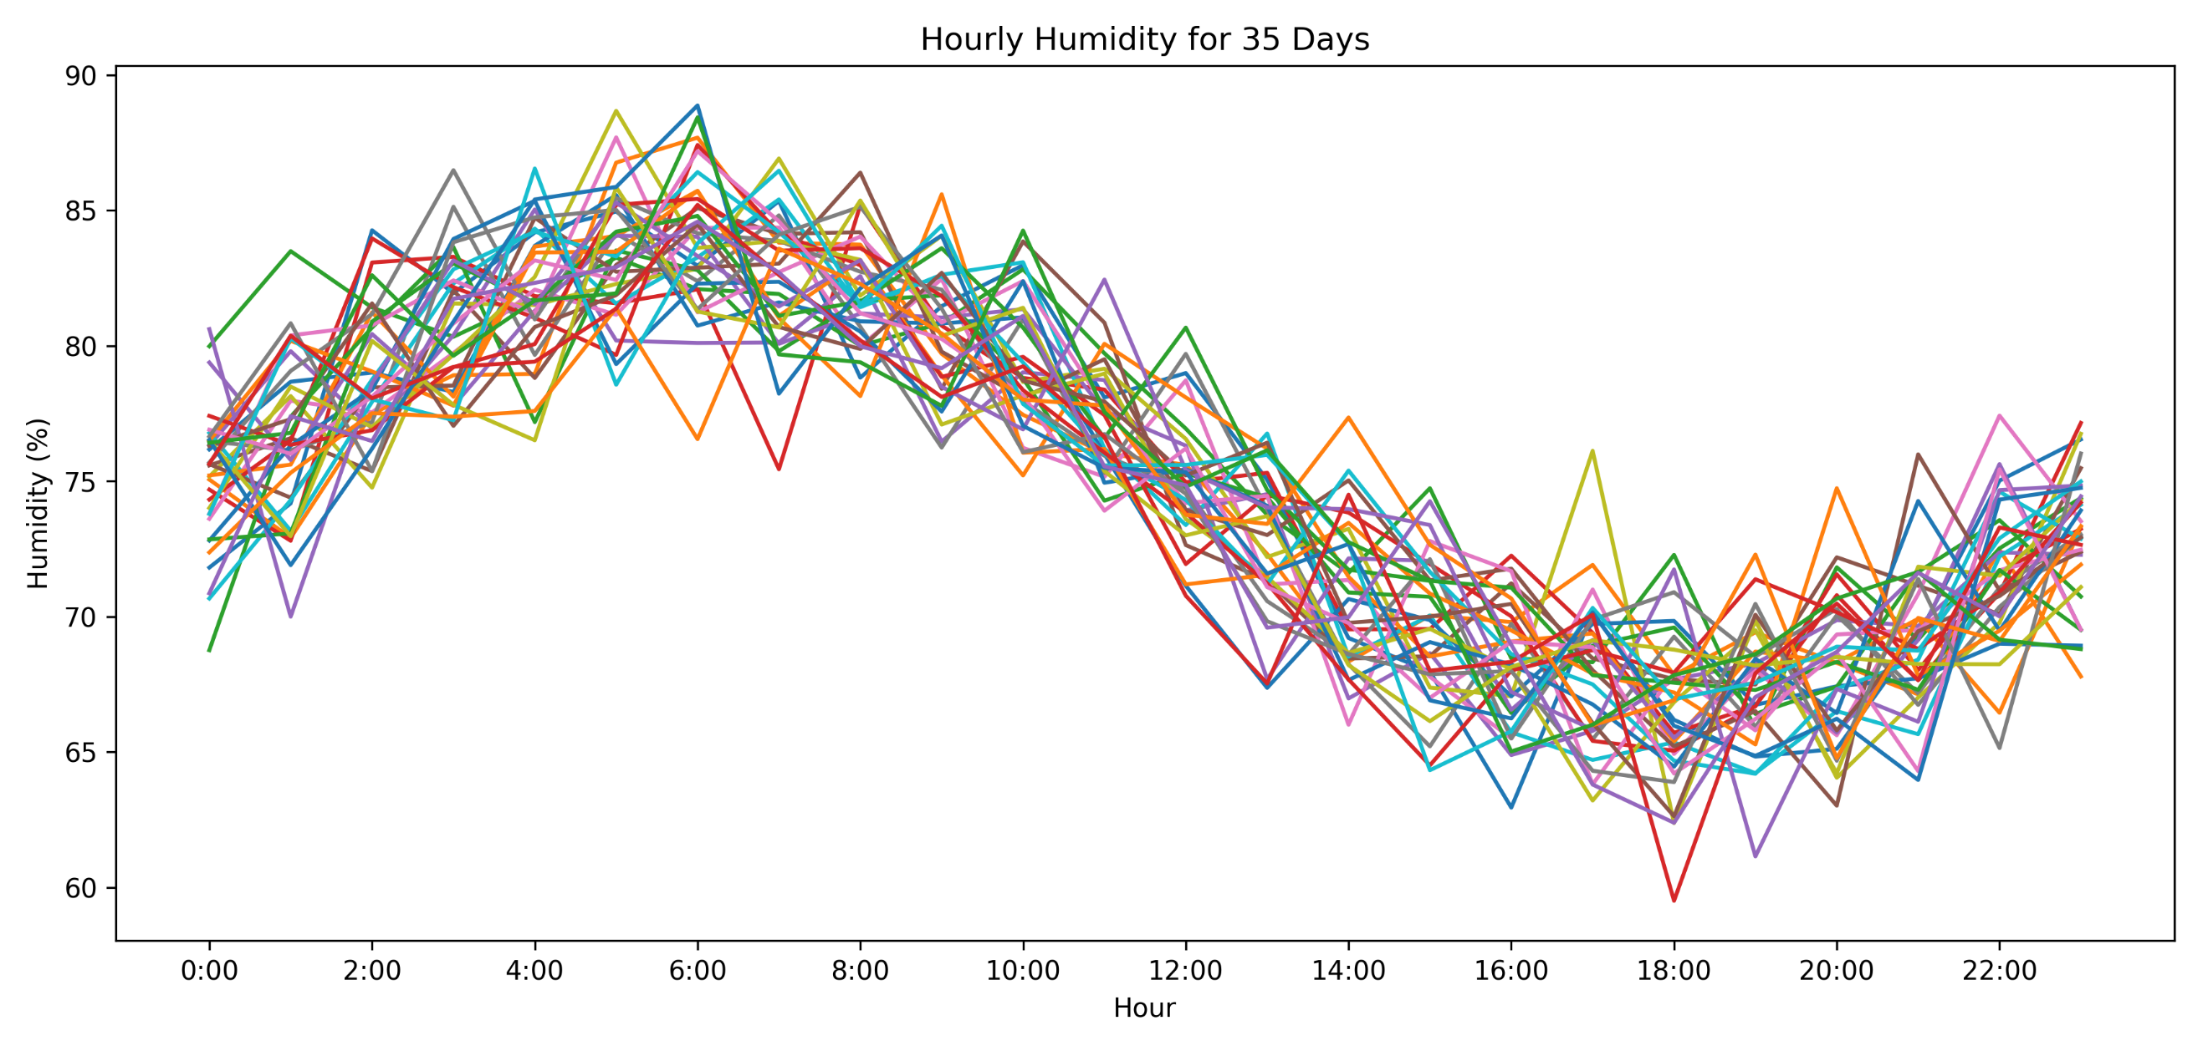

controlled environment shed, ammonia concentrations remained below the threshold level of 25 ppm for the duration of the experiment, with minimal fluctuations. This was achieved through the proactive activation of ventilation fans in response to elevated ammonia levels, ensuring optimal air quality within the shed.

In contrast, the traditional setup exhibited occasional spikes in ammonia concentrations, reaching levels above the acceptable threshold. These spikes coincided with periods of poor ventilation and inadequate air circulation, highlighting the importance of effective environmental management in mitigating ammonia buildup and maintaining poultry health.

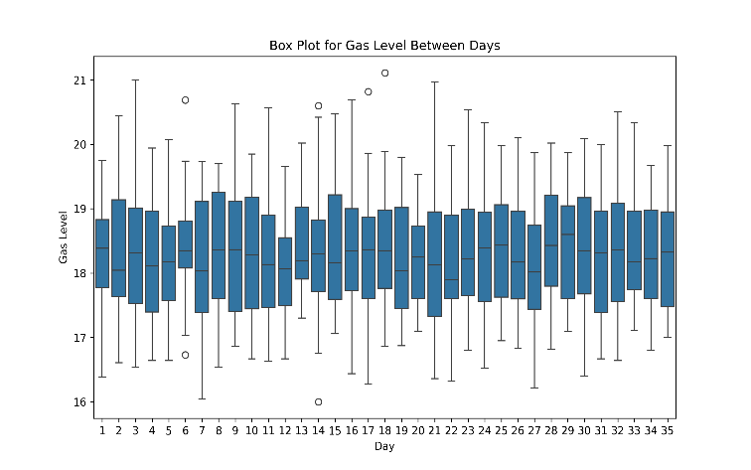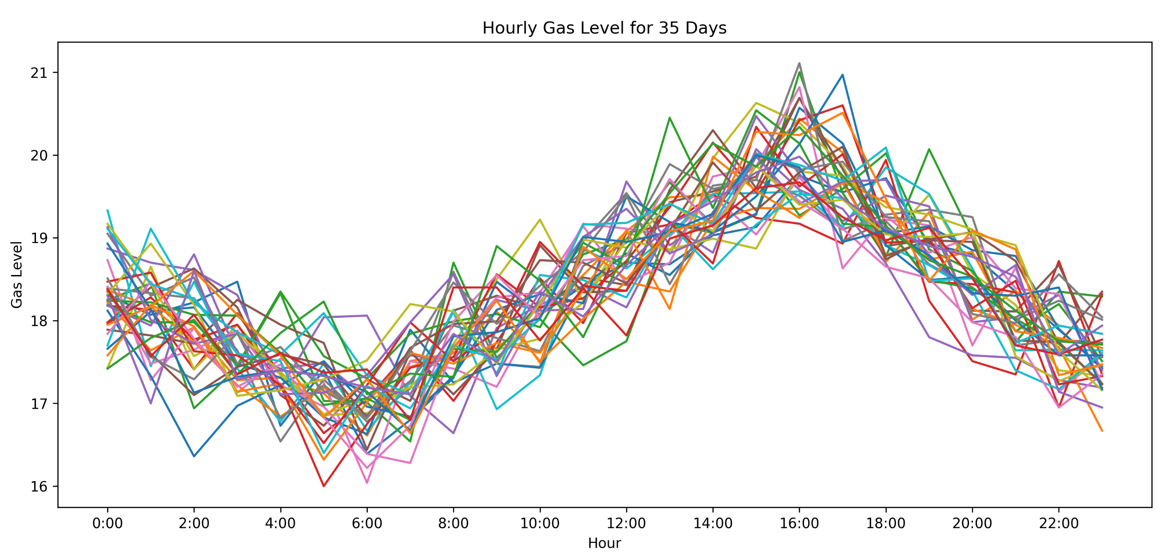

Figure 7: Gas Level Vs Hour For 35 Days

**4.2 Controlled vs Traditional Environment**

|  |  |  |  |  |  |  |
| --- | --- | --- | --- | --- | --- | --- |
| **Parameter** | **Traditional** | | | **Controlled** | | |
| **Temperature** | **Humidity** | **Gas Level** | **Temperature** | **Humidity** | **Gas Level** |
| **count** | 840.00 | 840.00 | 840.00 | 840.00 | 840.00 | 840.00 |
| **mean** | 17.60 | 54.97 | 27.00 | 22.70 | 75.11 | 18.31 |
| **std** | 4.12 | 12.86 | 7.83 | 1.57 | 6.23 | 0.95 |
| **min** | 3.63 | 24.32 | 5.59 | 18.87 | 59.51 | 16.00 |
| **25%** | 14.82 | 45.40 | 21.59 | 21.51 | 69.71 | 17.57 |
| **median** | 17.46 | 55.57 | 26.57 | 22.54 | 75.30 | 18.25 |
| **75%** | 20.35 | 65.15 | 32.73 | 23.89 | 80.67 | 19.04 |
| **max** | 30.17 | 85.06 | 55.47 | 26.92 | 88.87 | 21.11 |

The comparison of temperature, humidity, and gas levels between the two types of sheds revealed notable distinctions in environmental conditions. In the controlled environment shed, where automated systems regulated these variables, temperature and humidity remained relatively stable within optimal ranges. Conversely, the traditional shed exhibited greater fluctuations influenced by external weather conditions, resulting in less consistent levels. Similarly, gas levels, particularly ammonia concentrations, were better managed in the controlled environment shed, thanks to automated monitoring and ventilation systems, whereas levels in the traditional shed varied more widely. Overall, the comparison highlights the efficacy of automation in maintaining more favorable environmental conditions for poultry welfare and productivity. Figure 9 shows the standard deviation (Std) of temperature, humidity, and gas

Table 2: Data Summary

level for each hour of the day in the controlled and traditional sheds. The green curve represents the controlled environment, and the blue curve represents the traditional shed.

Figure 8: Parameter Comparison

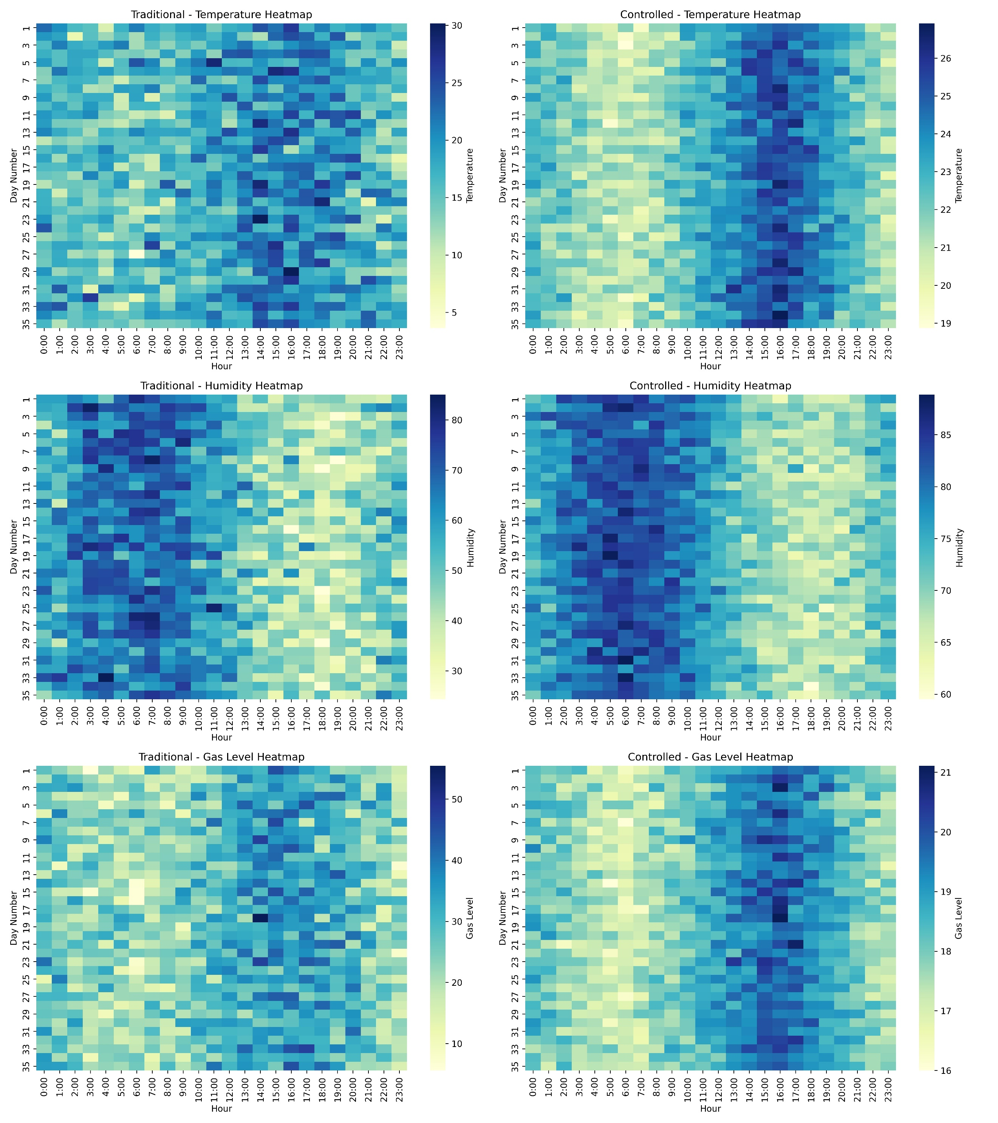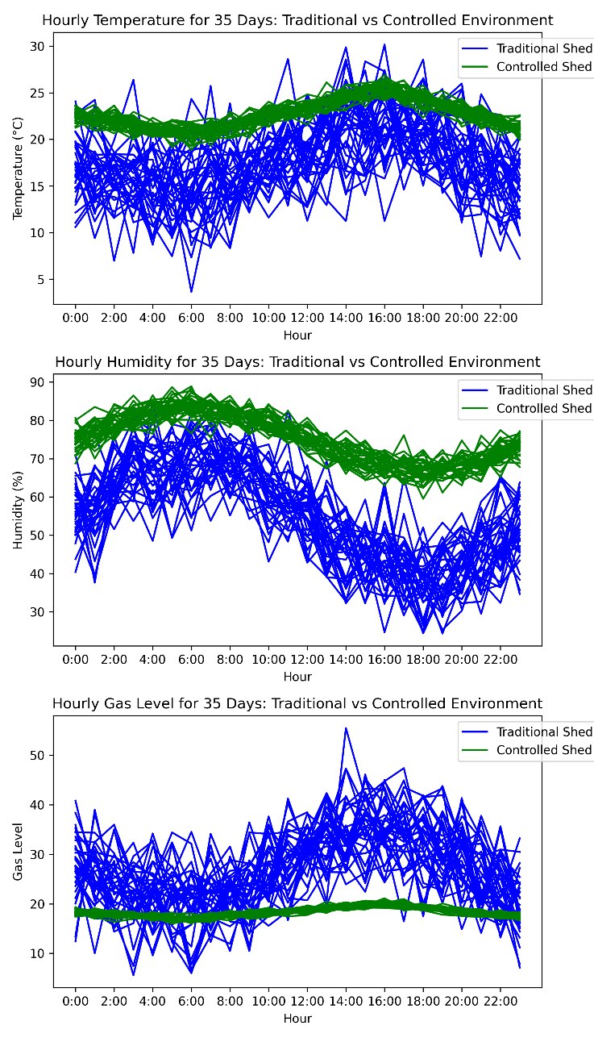

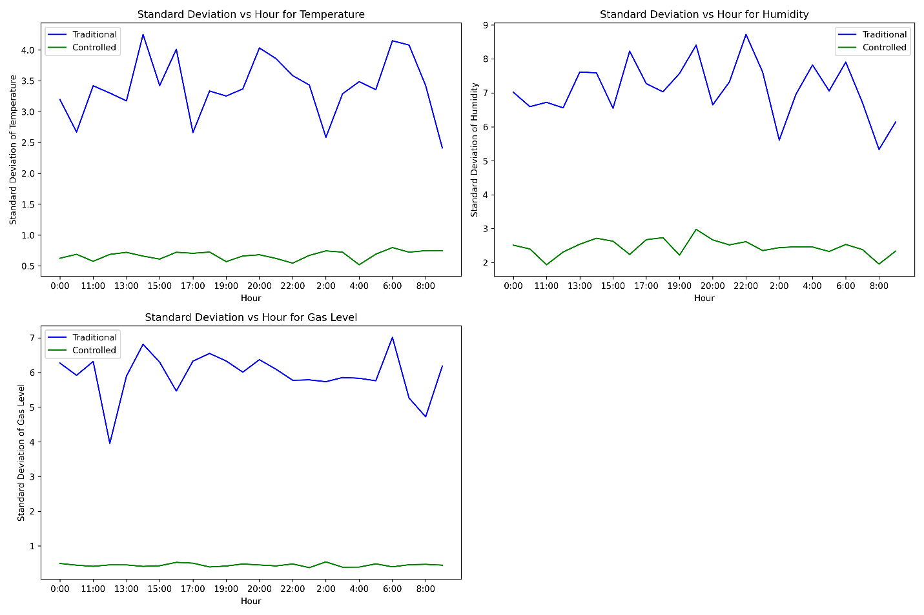As evident from the graphs, the standard deviation of all three parameters (temperature, humidity, and gas level) is significantly lower in the controlled environment (green curve) compared to the traditional Figure 9: Standard Deviation Comparison

shed (blue curve) throughout the day. This indicates that the automated system in the controlled environment effectively maintained more stable conditions for temperature, humidity, and gas level compared to the traditional shed, which likely experienced larger fluctuations throughout the day. To assess the statistical significance of the differences in temperature, humidity, and gas levels between the traditional and controlled environments, independent t-tests were conducted.

|  |  |  |
| --- | --- | --- |
| Parameter | t-statistic | p-value |
| Temperature | -33.510 | 3.370e-169 |
| Humidity | -40.842 | 4.622e-230 |
| Gas Level | 31.925 | 2.516e-148 |

Table 3: t-test Summary

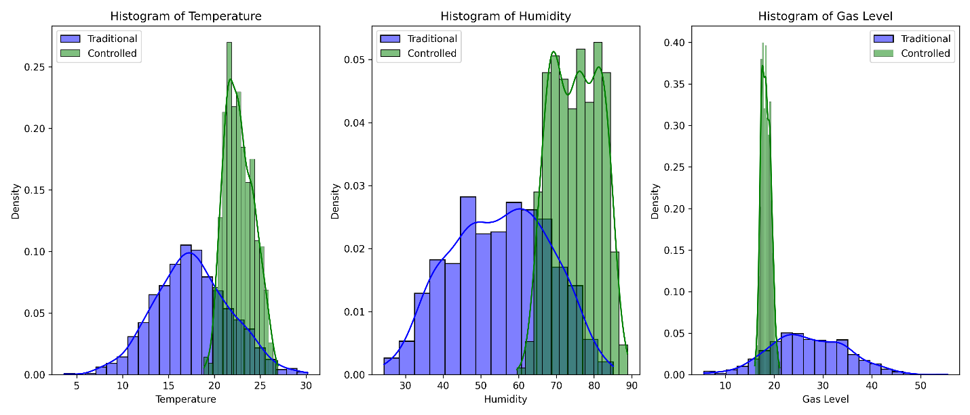For temperature, the t-statistic was -33.51 with a p-value of 3.37e-169, indicating a highly significant difference, with the controlled environment maintaining higher and more stable temperatures. For humidity, the t-statistic was -40.84 with a p-value of 4.62e-230, also indicating a highly significant difference, with the controlled environment maintaining higher and more consistent humidity levels. For gas levels, the t-statistic was 31.93 with a p-value of 2.52e-148, showing a significant reduction in ammonia levels in the controlled environment compared to the traditional setup. These results confirm that the automated system in the controlled environment effectively maintained more favorable conditions for poultry farming. The histograms depict the frequency of observations for each range of values (bins) for all three parameters. The green bars represent the controlled environment, and the blue bars represent the traditional shed. The corresponding density curves are also shown to illustrate the overall distribution of the data. The controlled environment (green histogram) exhibits a narrower

Figure 10: Histogram and Distribution Comparison

distribution of temperature compared to the traditional shed (blue histogram). This suggests that the automated system effectively maintained a more stable temperature with fewer variations around a set point in the controlled environment. The distribution of humidity in the controlled environment (green histogram) appears more centered compared to the traditional shed (blue histogram). While the controlled environment shows some bimodality, which might be due to external humidity fluctuations since our shed wasn't completely sealed, it still indicates significantly better humidity control compared to the traditional shed. The gas level distribution in the controlled environment (green histogram) shows lower values and a narrower spread compared to the traditional shed (blue histogram). This implies that the controlled environment effectively maintained lower ammonia levels with less fluctuation, contributing to a healthier environment for the chickens.

**4.3 Ordinary Least Squares (OLS) regression**

Humidity and Gas Levels

In the first OLS regression model, we assessed the influence of humidity on gas levels. The model showed an R-squared value of 0.418, indicating that 41.8% of the variability in gas levels could be explained by changes in humidity. The F-statistic was 601.0, with an exceptionally significant p-value of 1.72e-100, demonstrating the robustness of the model. The regression coefficient for humidity was -0.0985 (p < 0.0001), indicating a negative relationship; specifically, for every 1% increase in humidity, gas levels decreased by approximately 0.0985 ppm. The constant term was 25.7104 (p < 0.0001), representing the estimated gas level when humidity is zero. This inverse relationship might be due to the fact that higher humidity can dilute the concentration of gases, reducing their levels within the shed.

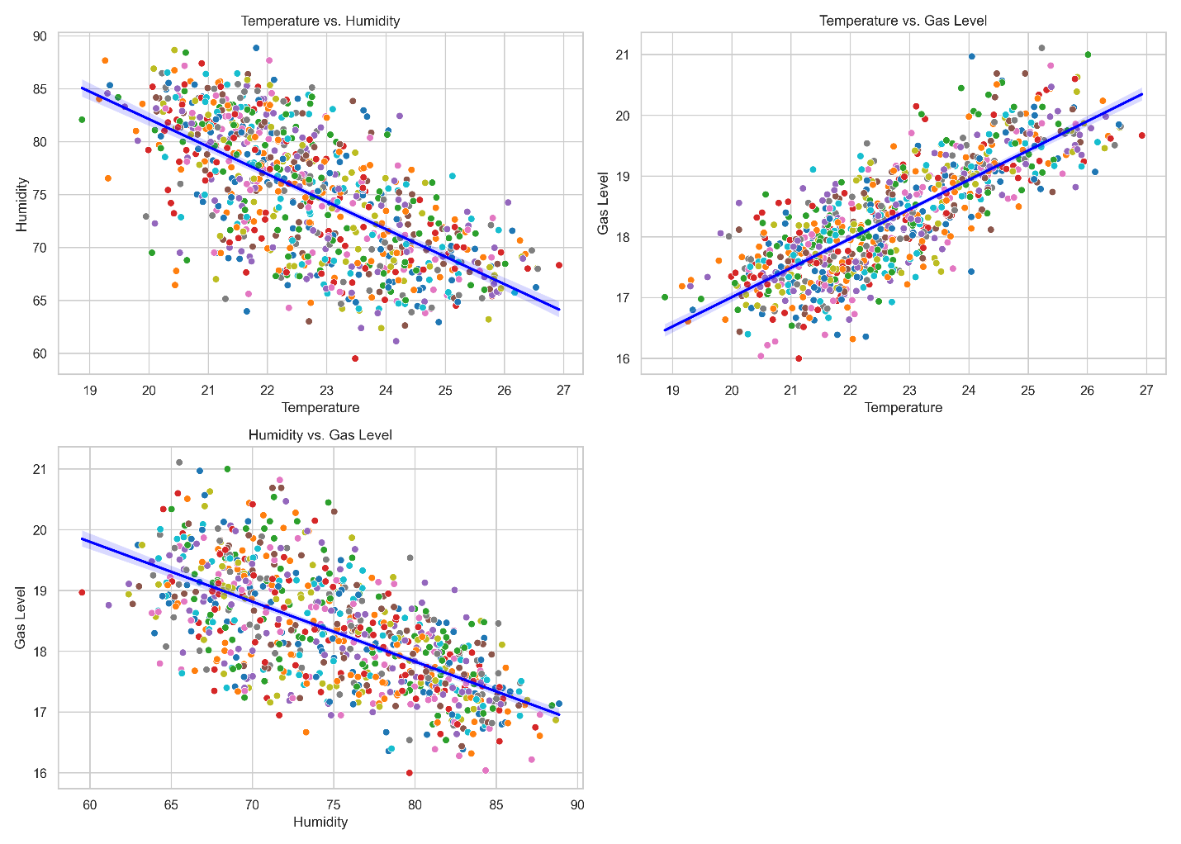Temperature and Gas Levels

Figure 10: Regression Graphs

The second OLS regression model examined the effect of temperature on gas levels. This model had an R-squared value of 0.634, indicating that 63.4% of the variability in gas levels was accounted for by temperature. The F-statistic was 1453, with a p-value of 3.50e-185, further confirming the model's significance. The coefficient for temperature was 0.4825 (p < 0.0001), suggesting a positive relationship; for every 1°C increase in temperature, gas levels increased by approximately 0.4825 ppm. The constant term was 7.3595 (p < 0.0001), indicating the gas level when the temperature is zero. This strong positive correlation can be attributed to the increased diffusion of gases at higher temperatures, leading to higher gas levels in the shed.

Temperature and Humidity

The third OLS regression model explored the relationship between temperature and humidity. The model produced an R-squared value of 0.428, meaning that 42.8% of the variability in humidity could be explained by temperature changes. The F-statistic was 626.7, with a p-value of 1.04e-103, indicating strong model significance. The regression coefficient for temperature was -2.6012 (p < 0.0001), indicating a negative relationship; for every 1°C increase in temperature, humidity decreased by approximately 2.6012%. The constant term was 134.1639 (p < 0.0001), representing the estimated humidity level when temperature is zero. This inverse relationship is likely due to the fact that higher temperatures can enhance the evaporation of water, thereby reducing the humidity levels within the shed.

|  |  |  |  |
| --- | --- | --- | --- |
| **Regression Analysis** | **Humidity vs. Gas Levels** | **Temperature vs. Gas Levels** | **Temperature vs. Humidity** |
| Dependent Variable | Gas Level | Gas Level | Humidity |
| Independent Variable | Humidity | Temperature | Temperature |
| R-squared | 0.418 | 0.634 | 0.428 |
| F-statistic | 601 | 1453 | 626.7 |
| Prob (F-statistic) | 1.72E-100 | 3.50E-185 | 1.04E-103 |
| Coefficient | -0.0985 | 0.4825 | -2.6012 |
| Std. Error | 0.004 | 0.013 | 0.104 |
| t-value | -24.516 | 38.116 | -25.033 |
| P>|t| | 0 | 0 | 0 |
| 95% Confidence Interval | [-0.106, -0.091] | [0.458, 0.507] | [-2.805, -2.397] |
| Constant | 25.7104 | 7.3595 | 134.1639 |
| Std. Error (Constant) | 0.303 | 0.288 | 2.365 |
| t-value (Constant) | 84.934 | 25.545 | 56.737 |
| P>|t| (Constant) | 0 | 0 | 0 |
| 95% Confidence Interval (Constant) | [25.116, 26.305] | [6.794, 7.925] | [129.523, 138.805] |

Table 4: OLS Summary

**4.4 Chicken Growth Summary**

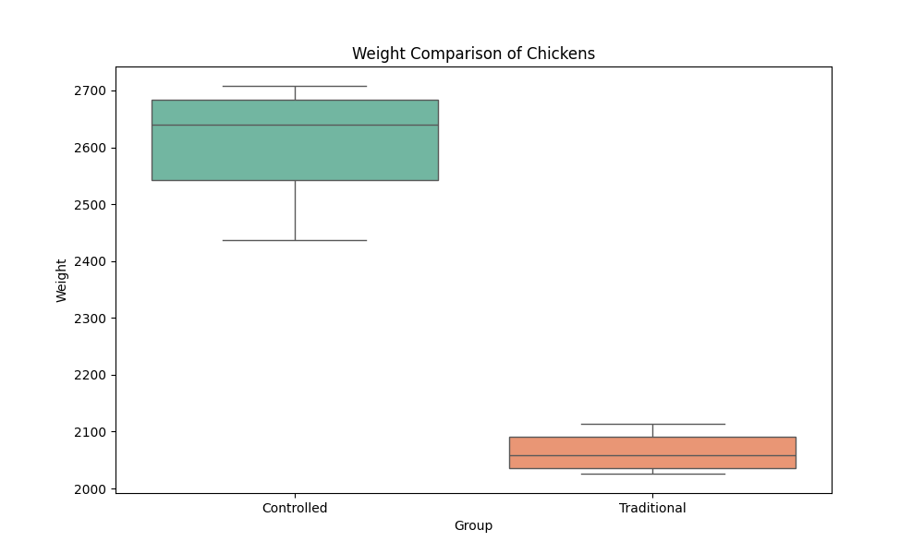Weight Gain: Chickens raised in the controlled environment achieved a significantly higher average weight

Figure 11: Chicken Weight Distribution

compared to those in the traditional shed. The mean weight of chickens in the controlled environment was 2605.36 grams, while the mean weight in the traditional shed was 2064.61 grams. This translates to a 26.19% increase in weight gain for chickens raised in the controlled environment.

|  |  |  |  |  |  |  |  |  |  |  |  |  |
| --- | --- | --- | --- | --- | --- | --- | --- | --- | --- | --- | --- | --- |
| Shed͢͢͢  Days | T1(Controlled) | | | | | | T2(Traditional) | | | | | |
| R1 | R2 | R3 | R4 | R5 | R6 | R1 | R2 | R3 | R4 | R5 | R6 |
| 0-14 days | 335 | 324 | 298 | 320 | 341 | 338 | 330 | 314 | 305 | 325 | 306 | 303 |
| 14-21 days | 886 | 793 | 779 | 870 | 895 | 810 | 798 | 749 | 75 | 793 | 763 | 754 |
| 21-28 days | 1768 | 1664 | 1772 | 1629 | 1904 | 1795 | 1414 | 1401 | 1383 | 1450 | 1408 | 1470 |
| 28-35 days | 2523 | 2679 | 2684 | 2708 | 2437 | 2600 | 2026 | 2034 | 2040 | 2076 | 2113 | 2097 |
| Gain | 26.19% | | | | | | | | | | | |
| Count | 15 | 15 | 15 | 15 | 15 | 15 | 15 | 15 | 15 | 15 | 15 | 15 |
| Final Count | 14 | 14 | 15 | 14 | 15 | 13 | 12 | 11 | 12 | 13 | 12 | 13 |
| Mortality | 94.4% | | | | | | 81.1% | | | | | |
| Gain | 13.33% | | | | | | | | | | | |

Table 5: Chicken Weight Data Summary

Mortality Rate: The controlled environment also demonstrated a positive impact on chicken survival. The mortality rate in the controlled environment was 94.4%, compared to 81.1% in the traditional shed. This represents a 13.33% improvement in chick survival with the use of automation for environmental control.

**Chapter 5**

**Conclusion**

**5.1 Interpretation of the Results in Relation to the Research Objectives**

Interpreting our results in light of our research objectives, we've found compelling evidence supporting the effectiveness of automation in poultry farming under harsh weather conditions in Bangladesh. Our controlled environment sheds, equipped with advanced technology for temperature and humidity control, outperformed traditional setups, resulting in a remarkable 26.19% increase in growth rates and a 13.33% reduction in mortality rates. These sheds demonstrated superior regulation of temperature and humidity, minimizing stressors on poultry and promoting optimal growth conditions.

Furthermore, our study highlighted the importance of gas level monitoring and ventilation systems in controlling harmful gases like ammonia. By integrating sensors and automated fans, we maintained a healthy indoor environment, reducing the risk of respiratory ailments among poultry. These findings underscore the potential of automation to enhance sustainability and resilience in poultry farming, particularly in regions prone to extreme weather events like Bangladesh. Through proactive environmental management, farmers can mitigate adverse effects and optimize production outcomes, paving the way for a more sustainable poultry industry

**5.4 Limitations of the Study and Suggestions for Future Research**

While our research provides valuable insights into the efficacy of automation in poultry farming, it is essential to acknowledge certain limitations that may impact the interpretation and generalizability of our findings. Additionally, identifying areas for further exploration and refinement can guide future research endeavors aimed at advancing the field of automated poultry production.

Limitations:

Our study, conducted in Dinajpur, Bangladesh, may not fully generalize to other regions due to varying environmental and socioeconomic factors. Limited by a specific time frame, focusing on the winter season, our study suggests the need for longer-term monitoring to understand seasonal dynamics and sustained automation effects. While promising, our study's sample size was modest, and enhancing it with diverse breeds and management practices could improve representativeness.

Future Research:

Conducting multi-location studies and longitudinal assessments across diverse climates and landscapes would enhance understanding and scalability. Integrating precision agriculture techniques and fostering interdisciplinary collaborations can optimize automated systems and address complex challenges. Stakeholder engagement and knowledge exchange are vital for translating research outcomes into actionable policies and widespread adoption.

**5.3 Recommendations for Policymakers and Industry Stakeholders**

In light of the key findings and implications of our research on the role of automation in poultry farming, we propose the following recommendations for policymakers and industry stakeholders to foster sustainable agricultural development, enhance food security, and promote the welfare of poultry farmers and consumers:

1. Incentivize Technology Adoption:

Policymakers should implement incentives, subsidies, and support mechanisms to encourage the adoption of automation technologies in poultry farming. This includes providing financial assistance for the installation of controlled environment sheds, purchase of automated equipment, and training programs to enhance technical skills among farmers.

2. Develop Regulatory Frameworks:

Establish robust regulatory frameworks that promote animal welfare standards, environmental sustainability, and food safety in poultry production. This entails setting guidelines for the design, operation, and maintenance of automated farming systems, as well as monitoring and enforcement mechanisms to ensure compliance with industry standards.

3. Invest in Research and Development:

Allocate funding and resources for research and development initiatives aimed at advancing automation technologies, precision farming techniques, and sustainable practices in poultry farming. This includes supporting interdisciplinary research collaborations, technology transfer programs, and innovation hubs to drive continuous improvement and technological innovation in the agricultural sector.

4. Enhance Infrastructure and Connectivity:

Improve access to essential infrastructure, including electricity, water supply, and telecommunications, in rural areas to facilitate the deployment of automation technologies. Policymakers should prioritize investments in rural infrastructure development and broadband connectivity to enable seamless data transmission, remote monitoring, and real-time management of poultry farms.

5. Promote Knowledge Transfer and Capacity Building:

Facilitate knowledge transfer and capacity building initiatives to empower farmers with the necessary skills, knowledge, and resources to adopt and effectively utilize automation technologies. This includes organizing training workshops, extension services, and knowledge exchange programs that provide hands-on training, technical support, and best practices guidance to poultry farmers.

6. Foster Collaboration and Public-Private Partnerships:

Encourage collaboration and partnerships between government agencies, research institutions, academia, industry stakeholders, and civil society organizations to co-create innovative solutions, share best practices, and address common challenges in poultry farming. Public-private partnerships can leverage complementary expertise, resources, and networks to accelerate technology adoption and promote sustainable development across the agricultural value chain.

7. Prioritize Sustainability and Resilience:

Integrate sustainability principles and resilience-building strategies into agricultural policies, programs, and initiatives. This includes promoting agroecological approaches, renewable energy solutions, and circular economy practices that minimize environmental impact, enhance resource efficiency, and build resilience to climate change and other external shocks.

References

[1] S. K. Raha, “Poultry industry in Bangladesh: is it growing?,” *Bangladesh J. Agric. Econ.*, 2007, Accessed: May 09, 2024. [Online]. Available: https://www.semanticscholar.org/paper/Poultry-industry-in-Bangladesh%3A-is-it-growing-Raha/f9fbb1e850aa75d507a13558eae3b5d6d7ed7e43

[2] “Bangladesh,” One Health Poultry Hub. Accessed: May 09, 2024. [Online]. Available: https://www.onehealthpoultry.org/where-we-work/bangladesh/

[3] “Persistent cold hits poultry farms hard.” Accessed: May 09, 2024. [Online]. Available: https://www.newagebd.net/article/223866/persistent-cold-hits-poultry-farms-hard

[4] Y. Karmoker, “Self Sufficiency in Protein: Poultry Industry in Bangladesh,” Business Inspection BD. Accessed: May 09, 2024. [Online]. Available: https://businessinspection.com.bd/poultry-industry-in-bangladesh/

[5] . B. K., . N. E., . A. Y., . E. L., and . M. M., “Effect of Environmental Conditions in Poultry Houses on the Performance of Laying Hens,” *Int. J. Poult. Sci.*, vol. 5, no. 1, pp. 26–30, Dec. 2005, doi: 10.3923/ijps.2006.26.30.

[6] L. J. Lara and M. H. Rostagno, “Impact of Heat Stress on Poultry Production,” *Animals*, vol. 3, no. 2, Art. no. 2, Jun. 2013, doi: 10.3390/ani3020356.

[7] I. Ncro, L. Rn, U. Ns, and N. Le, “CLIMATE CHANGE IN POULTRY PRODUCTION SYSTEM - A REVIEW,” *Int. J.*, vol. 10.

[8] M. Zeyad *et al.*, “Design and Implementation of Temperature & Relative Humidity Control System for Poultry Farm,” in *2020 International Conference on Computational Performance Evaluation (ComPE)*, Jul. 2020, pp. 189–193. doi: 10.1109/ComPE49325.2020.9200032.

[9] K. Shahzad *et al.*, “Experiments on Energy-Efficient Evaporative Cooling Systems for Poultry Farm Application in Multan (Pakistan),” *Sustainability*, vol. 13, no. 5, Art. no. 5, Jan. 2021, doi: 10.3390/su13052836.

[10] G. Brunt, “Nutrition and heat stress - maintaining the balance : animal health,” Oct. 2014. Accessed: May 06, 2024. [Online]. Available: https://www.semanticscholar.org/paper/Nutrition-and-heat-stress-maintaining-the-balance-%3A-Brunt/619d8e742ead3272dbb16c3d9915e8a701331486

[11] I. U. Sheikh *et al.*, “Ammonia production in the poultry houses and its harmful effects,” *Int J Vet Sci Anim Husb*, vol. 3, no. 4, pp. 30–33, 2018.

[12] H. H. Kristensen and C. M. Wathes, “Ammonia and poultry welfare: a review,” *Worlds Poult. Sci. J.*, vol. 56, no. 3, pp. 235–245, 2000.

[13] F. C. Sousa, I. Tinôco, J. N. D. Silva, F. Baptista, C. F. Souza, and A. L. Silva, “Gas emission in the poultry production.” Accessed: May 06, 2024. [Online]. Available: https://www.semanticscholar.org/paper/Gas-emission-in-the-poultry-production-Sousa-Tin%C3%B4co/6c59a157a1d3a047ceab072e68eff03b4ddc3843

[14] “[PDF] Final Report: Evaluation of the Use of the AviHome Plenum Flooring System in Commercial Broiler Production in Georgia University of Georgia-Subcontractor for Conservation Innovation Grant Program (USDA) | Semantic Scholar.” Accessed: May 06, 2024. [Online]. Available: https://www.semanticscholar.org/paper/Final-Report%3A-Evaluation-of-the-Use-of-the-AviHome-Czarick-Fairchild/6a3d5157cb4ea21fff4a7a1c7ad2957f4c24d546

[15] A. Singh, K. D. Casey, W. D. King, A. J. Pescatore, R. S. Gates, and M. J. Ford, “Efficacy of urease inhibitor to reduce ammonia emission from poultry houses1,” *J. Appl. Poult. Res.*, vol. 18, no. 1, pp. 34–42, Mar. 2009, doi: 10.3382/japr.2008-00046.

[16] O. Lahav *et al.*, “A New Approach for Minimizing Ammonia Emissions from Poultry Houses,” *Water. Air. Soil Pollut.*, vol. 191, no. 1, pp. 183–197, Jun. 2008, doi: 10.1007/s11270-008-9616-0.

[17] M. Rothrock, A. Szögi, and M. Vanotti, “POULTRY LITTER USING GAS‐PERMEABLE MEMBRANES,” 2010. Accessed: May 06, 2024. [Online]. Available: https://www.semanticscholar.org/paper/POULTRY-LITTER-USING-GAS%E2%80%90PERMEABLE-MEMBRANES-Rothrock-Sz%C3%B6gi/a016c515eade667e5dc6eca6f614d7ddf759e5fb

[18] D. Bejan, T. Graham, and N. J. Bunce, “Chemical methods for the remediation of ammonia in poultry rearing facilities: A review,” *Biosyst. Eng.*, vol. 115, no. 3, pp. 230–243, Jul. 2013, doi: 10.1016/j.biosystemseng.2013.03.003.

[19] Z. H. C. Soh, M. H. Ismail, F. H. Otthaman, M. K. Safie, M. A. A. Zukri, and S. A. C. Abdullah, “Development of automatic chicken feeder using Arduino Uno,” *2017 Int. Conf. Electr. Electron. Syst. Eng. ICEESE*, pp. 120–124, Nov. 2017, doi: 10.1109/ICEESE.2017.8298402.

[20] S. Goswami and A. Dangi, “Implementation of automatic lighting and heating system for poultry farm using Arduino,” *Pharma Innov.*, vol. 11, no. 7S, pp. 1778–1781, Jul. 2022, doi: 10.22271/tpi.2022.v11.i7Sw.13986.

[21] G. P. Raghudathesh *et al.*, “Iot based intelligent poultry management system using Linux embedded system,” *2017 Int. Conf. Adv. Comput. Commun. Inform. ICACCI*, pp. 449–454, Sep. 2017, doi: 10.1109/ICACCI.2017.8125881.